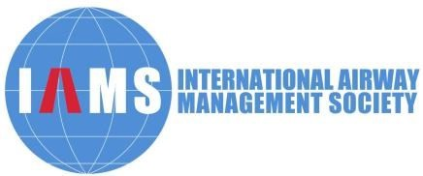

International Airway Management Society (IAMS) Wellead Young Scholars Travel Award for WAMM 2025

**Application Form**

|  |  |  |  |
| --- | --- | --- | --- |
| Name |  | Nationality |  |
| Gender |  | age |  |
| Professional Title |  | | |
| Institution |  | | |
| Address |  | | |
| Telephone |  | Fax |  |
| Email |  | | | |
| Education  Background |  | | | |
| Employment |  | | | |
| WAMM2025  Abstract | Copy submitted WAMM2025 abstract here | | | |
| Publications in journal, international conference abstracts: | | | | |
| Achievement of education and training, research in airway management: | | | | |
| Additional application supporting materials and comments: | | | | |